COMP 7500 - Lecture02: Interprocess Communication
: >85%, : 70-85%, : 55-70%, : 40-55%, : < 40%
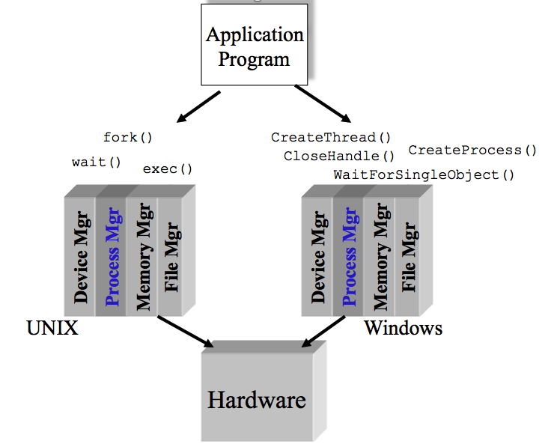
Exercise 1 (Microsoft Forms): Which one of the following is not a basic component in Microkernel? (30 seconds)
- Process manager
- Memory manager
- IPC: inter-process communications
- File manager

Exercise 2 (Microsoft Forms): Which one of the following items is not a design goal of a process manager? Hint: You should focus on OS management of application execution. (30 seconds)
- To improve CPU utilization
- To switch a processor among multiple processes
- To allocate memory resources to processes
- To use processor more efficiently

Exercise 3 (Microsoft Forms): The context-switch time is OS overhead. The context-switch overhead depends on the following factors except. (30 Seconds)
- The complexity of the OS and PCB B. Open source operating systems
- Multiple sets of registers per CPU D. Multiple contexts loaded at once

Exercise 4: What are advantages of process cooperation (30 Seconds)?

Exercise 5: What can be a potential problem if all the four tabs in a chrome browser are running in a single process? (1 Minutes)?

Exercise 6: Can you design a multiprocess architecture to solve problem described in Exercise 5? Hint: There are three types of cooperating processes

Exercise 7: What are two fundamental models of interprocess communication? Hint: How do two process talk with each other?

Exercise 8 (Microsoft Forms): Suppose two processes are exchanging a small amount of data, which interprocess communication model will you choose? Why? (30 Seconds)
- Shared Memory
- Shared Buffer
- Message Passing
- Message Chatting

Exercise 9 (Microsoft Forms): Which interprocess communication model is faster than its counterpart? Assumption: message-passing systems are implemented using system calls; shared-memory systems are implemented in the user space. (30 Seconds)
- Message Passing is faster
- Shared Memory is faster
- Shared Message is faster
- Two models are both fast

Exercise 10 (Microsoft Forms): Which interprocess communication model is easier to implement in a distributed system? (30 Seconds)
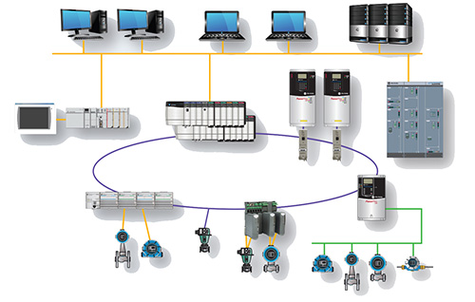
- Shared Memory is easier
- Message Passing is faster
- Message Passing is easier
- Two models are equally easy

